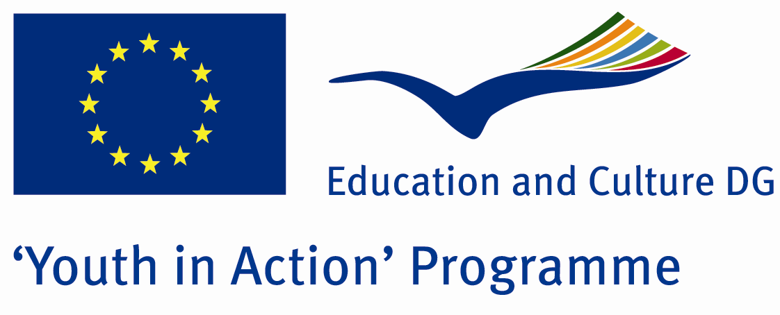

How Will Be The Weather

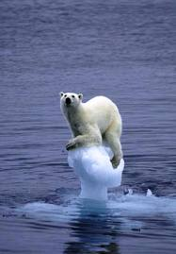

ACTION 1.1 – Youth Exchange

01-08th August, 2011

Amasya, TURKEY

ACTION 1.1 Youth Exchange
01-08th August, 2011
Amasya, TURKEY

Please contact directly to;
adventurerpeacepigeons@gmail.com

Project Summary; The global warming is one of the biggest and most complex problems of the human being. We are the only one on this earth causing this, and we are the only one who can solve this problem or slow it down. We all know that we can change this but we are not doing enough for that. In the last few years, human being has realised this problem seriously and started to move against. We, as the youngsters, are the ones who have to fight against this problem the most and we will mostly suffer from the results of it. If we need to have a better world, we need to understand what are the main reasons of global warming, see what we we are doing to the earth and what can we do against the global warming. To discuss this topic and understand this problem and share our ideas, this project will be a start for us. This project will also take interest to this warm theme again, and maybe more people will realise how dangerous it is. So join us!

Project Title; How will be the weather

Date and Venue ; 01-08th July, 2011 Amasya, Turkey .

Target Group ; Municipalities, City Councils and Non-Governmental organizations,
youth groups,culture and art groups,e.t.c

Participants ; 5 people from each country (over 18 -25 ). Totally 8 countries.

Conditions ; Accommodation, board and programme costs will be financed through European Commission Youth in Action Programme (Action 1.1). Travel costs will be reimbursed in 70% (APEX Tarrifs). Organizations from all 27 EU member countries plus Liechtenstein , Norway and Iceland are eligible to take part.

Working language: English

Organizer; Discovery And Adventure Group

How to apply: If you are interested, please send your Part III forms to
0090 216 483 21 67 by FAX please. (Fulfilled Part III which you can find in the attachment, of course signed and stamped) ..

Note: jpeg is not allowed..please send by fax…

Next step 2;
Original send via regular post to this address please:

Ertan DERİN
Öner İnşaat
Abdulhalik Renda Cd.
Parlar Sk. No:4 Pendik/İSTANBUL

If you have any questions you may contact with: adventurerpeacepigeons@gmail.com

Deadline for application; until 20th January 2011.

For Further information:
Contact Person
Ertan DERİN
Öner İnşaat
Abdulhalik Renda Cd.
Parlar Sk. No:4 Pendik/İSTANBUL

e-mail : adventurerpeacepigeons@gmail.com
Mobile : 0090 542 393 93 90
Fax : 0090 216 483 21 67

